# First Race:

Track: 11110011100011001110011101  
Source: DB  
 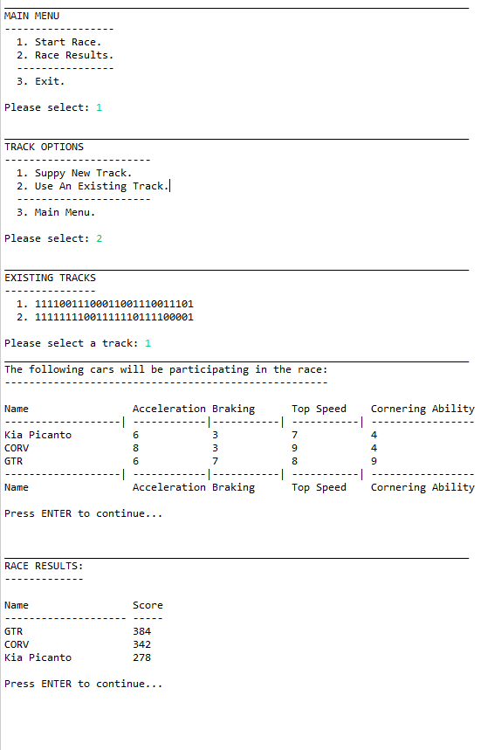

# Second Race:

Track: 11111111001111110111100001  
Source: DB

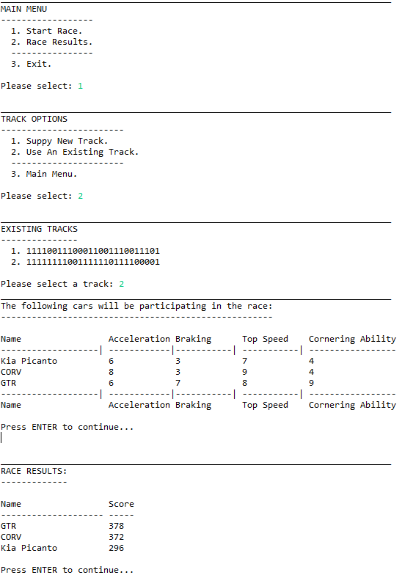

# 3rd Race

Track: 1111110111111111111111011001111  
Source: Manual Entry

